OPTIMIZING USER, GROUP, AND ROLE MANAGEMENT WITH ACCESS CONTROL AND WORKFLOWS

Team ID : NM2025TMID19832

Team Size : 4

Team Leader : AKASH V

Team member : ASHIM R

Team member : CHANDRU R

Team member : CIBIRAJ S

# PROBLEM STATEMENT:

In a small project management team consisting of a Project Manager (Alice) and a Team Member (Bob), there is a need to efficiently manage project tasks and ensure accountability throughout the project lifecycle. The current system lacks clear role definitions, access controls, and a structured workflow, leading to confusion regarding task assignments and progress tracking.

**Objectives**

1. Role Definition & Access Control

2. Task Management Application

3. Workflow Automation

4. Accountability & Transparency

5. Improved Collaboration

**Skills Required**

Creating Tables & Forms in ServiceNow (for project tasks).

Defining Roles & Access (Project Manager and Team Member).

Using Flow Designer (to automate task assignment and updates).

Applying ACLs (to control who can view or edit records).

Creating Reports & Dashboards (to track progress).

USERS

**How to Create a New User in ServiceNow**

1. Open ServiceNow.

2. Go to All → search “Users”.

3. Select Users under System Security.

4. Click New.

5. Enter the required user details.

6. Click Submit.

* To create another user, repeat the same steps with the new details and click Submit again.

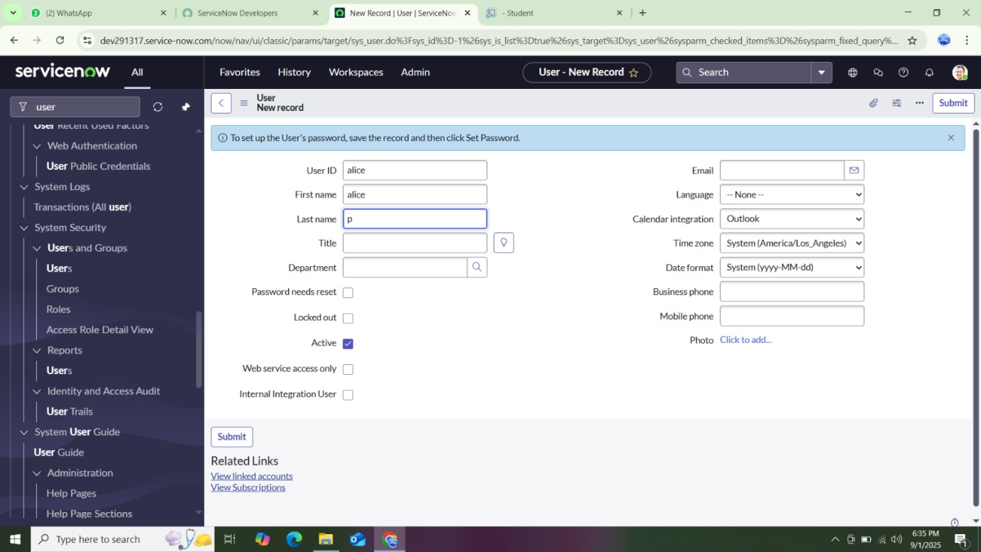

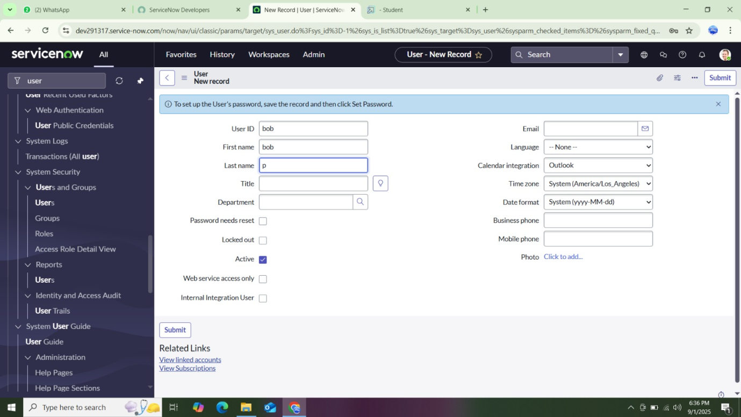

GROUPS

**How to Create a New Group in ServiceNow**

1. Open ServiceNow.

2. Go to All → search “Groups”.

3. Select Groups under System Security.

4. Click New

5. Enter the group details.

6. Click Submit.

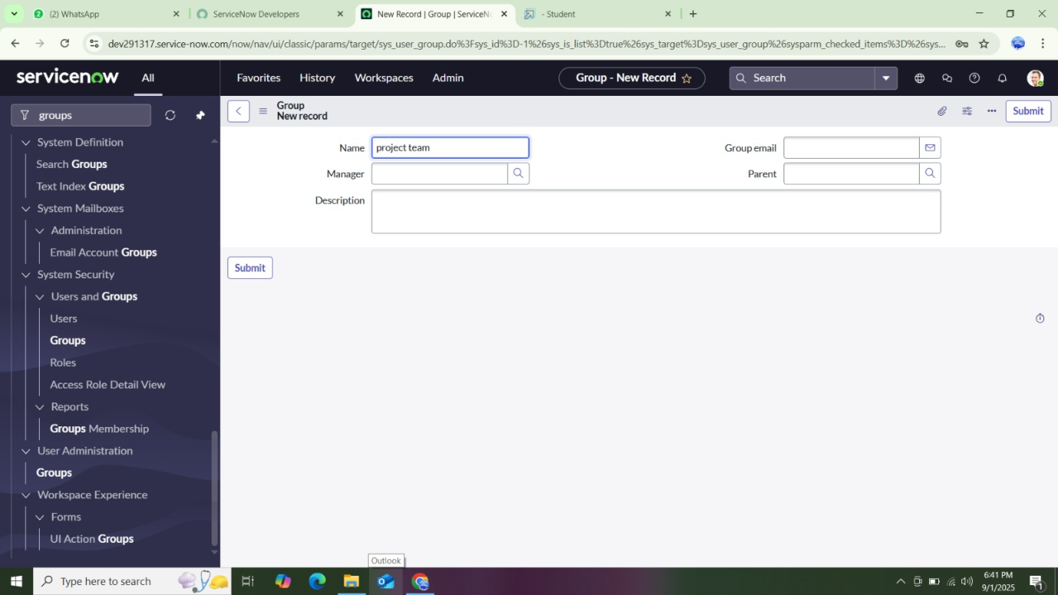

ROLES

**How to Create a New Role in ServiceNow**

1. Open ServiceNow.

2. Go to All → search “Roles”.

3. Select Roles under System Security.

4. Click New.

5. Enter the role details.

6. Click Submit.

7. To add another role (e.g., Team member), repeat the same steps and click Submit again.

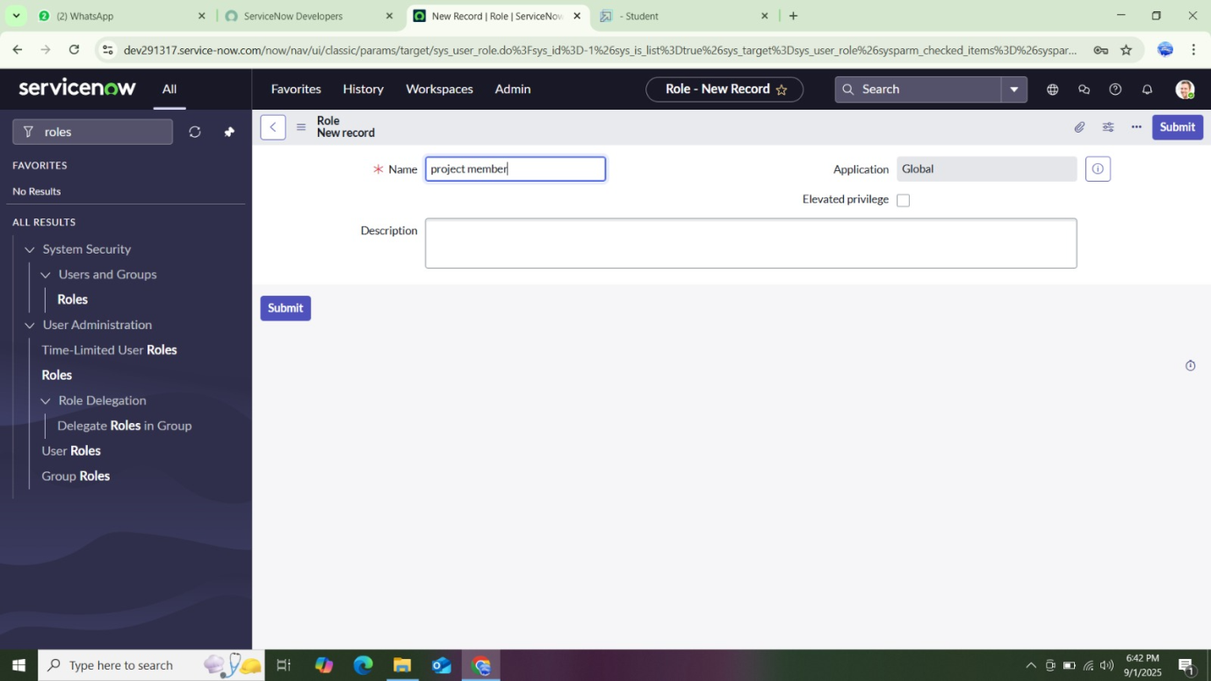

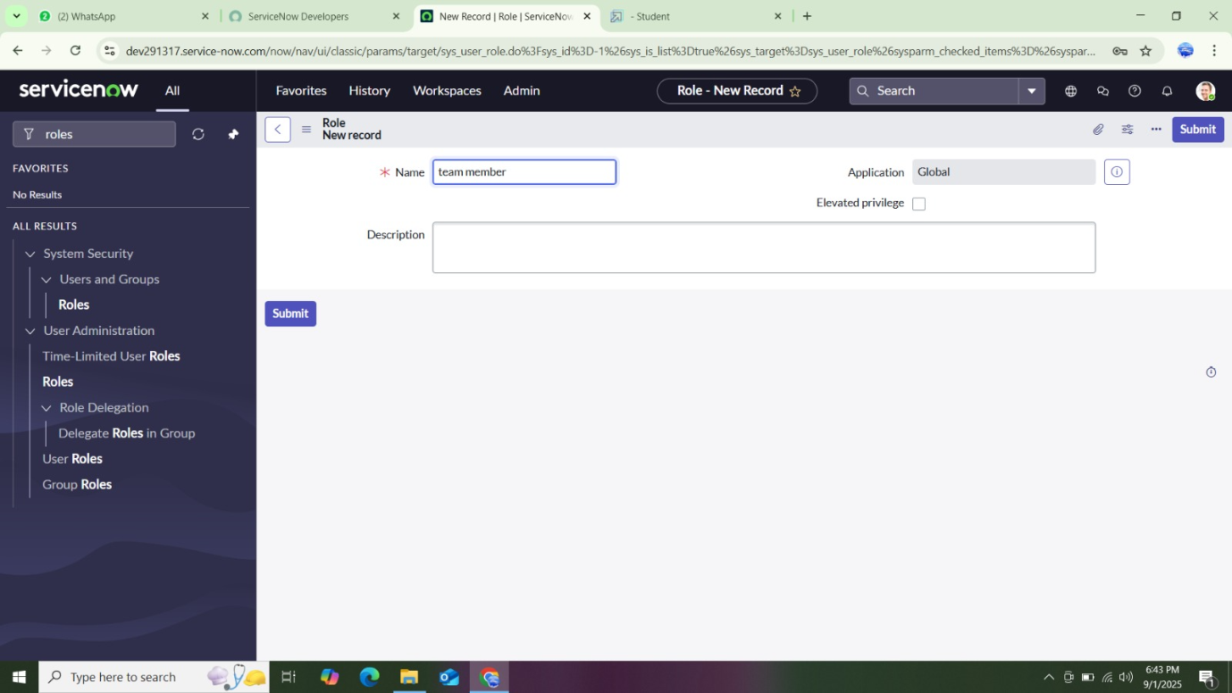

TABLES

**How to Create a New Table in ServiceNow**

1. Open ServiceNow.

2. Go to All → search “Tables”.

3. Select Tables under System Definition.

4. Click New.

5. Fill in the details:

Label: Project table

Check Create module & Create mobile module

New menu name: Project table

Add the required Table Columns

6. Click Submit.

7. To create another table, repeat the steps with:

Label: Task table 2

Fill in the given details\

Click Submit.

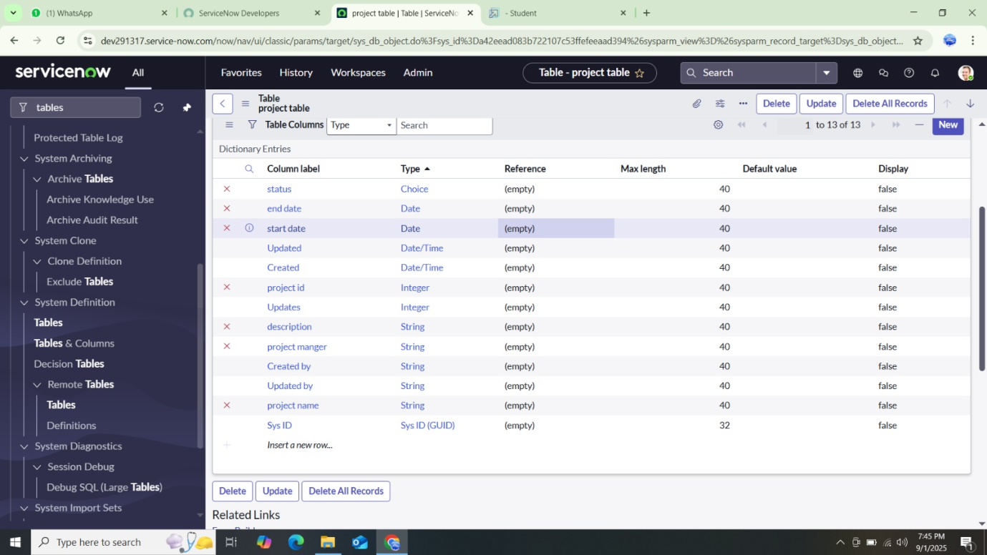

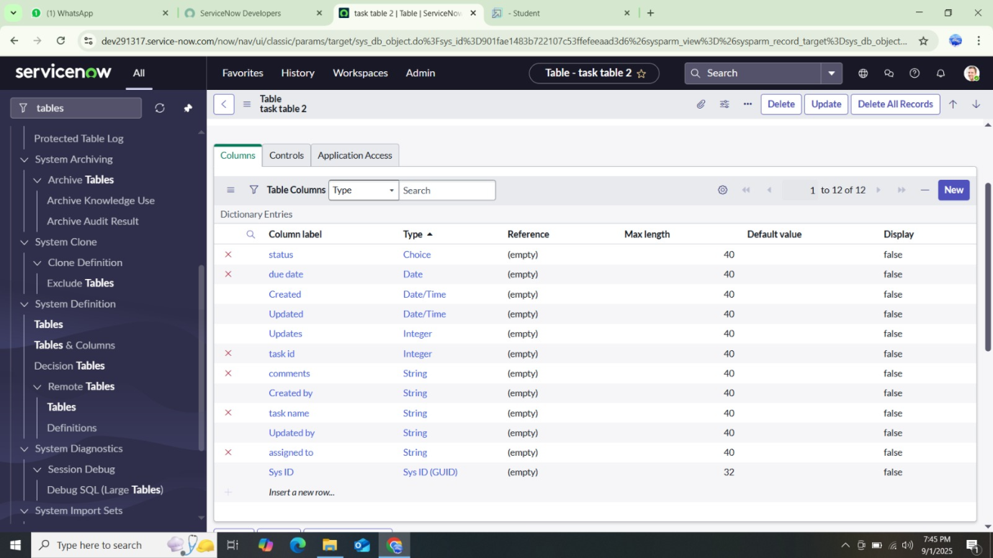

ASSIGN USERS TO GROUPS

**Assign users to project team group**

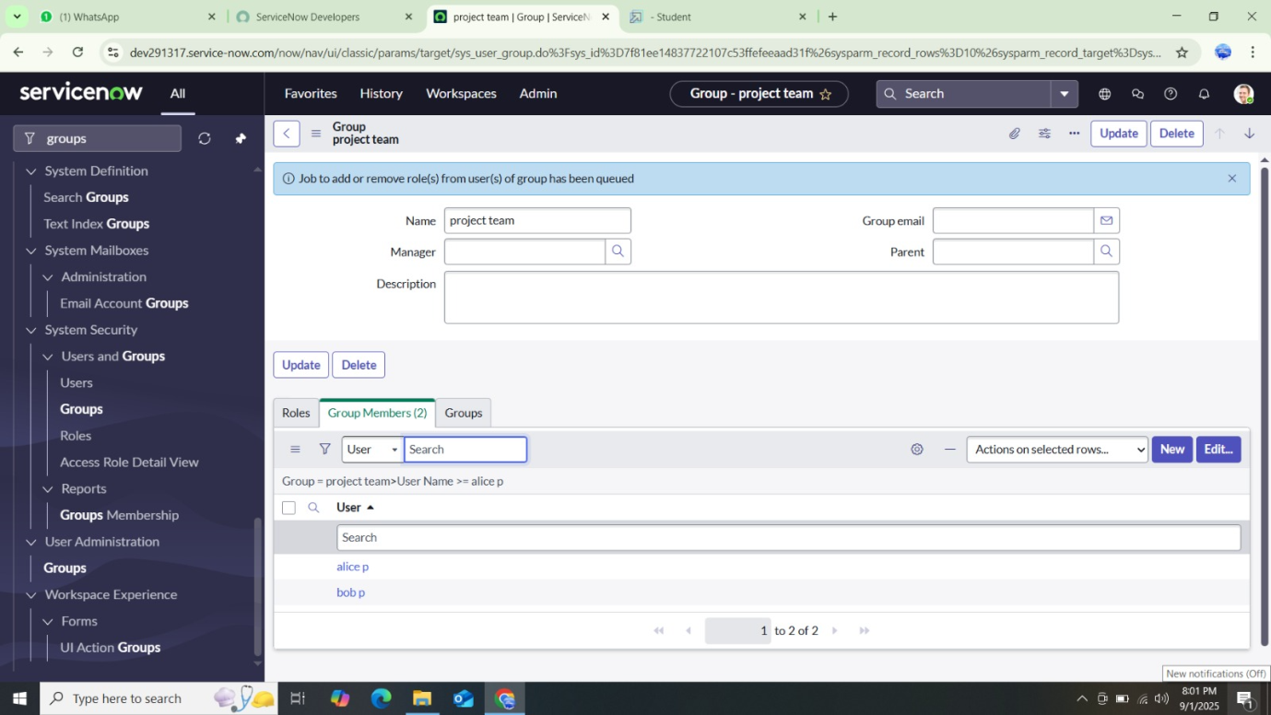

**How to Assign Users to the Project Team Group in ServiceNow**

1. Open ServiceNow.

2. Go to All → search “Groups”.

3. Select the Project Team Group.

4. In the Group Members section, click Edit

5. Select Alice P and Bob P.

6. Click Save.

ASSIGN ROLES TO USER

# Assign Roles to Alice (Project Manager User)

1. Open ServiceNow.

2. Go to All → search “Users”.

3. Select the Alice P (Project Manager) user.

4. In the Roles section, click Edit.

5. Add the Project Member role and click Save.

6. Again, click Edit and add:

u_project_table role

u_task_table role

7. Click Save and Update the form.

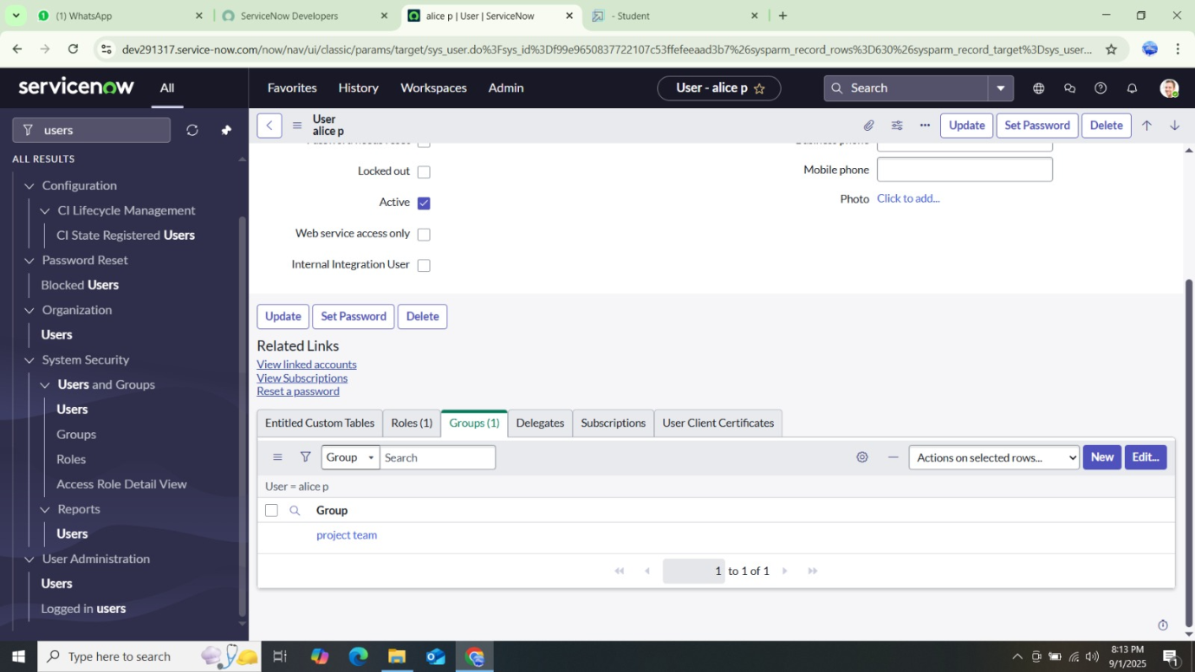

# Assign Roles to Bob (Team Member User)

1. Open ServiceNow.

2. Go to All → search “Users”.

3. Select the Bob P (Team Member) user.

4. In the Roles section, click Edit.

5. Add the Team Member role and the required Table Role, then click Save.

6. Click the Profile Icon → Impersonate User → Bob P.

7. Verify that Bob can access Task Table 2.

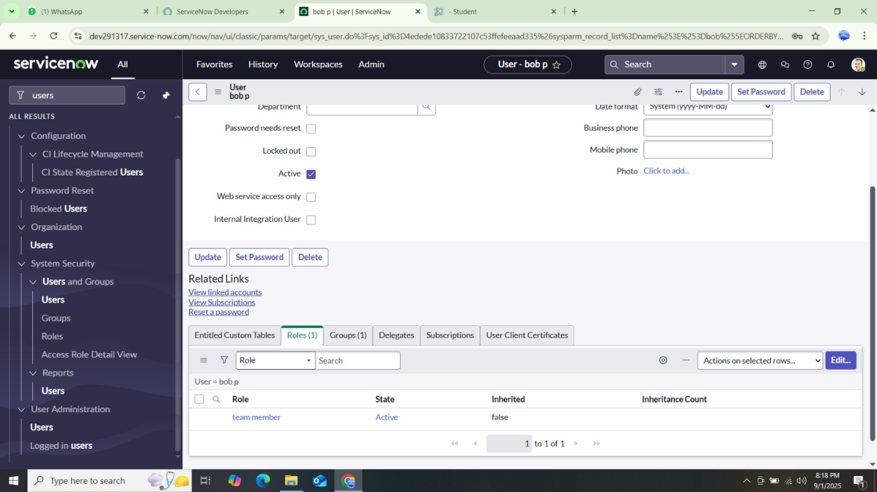

APPLICATION ACCESS

1. When a table is created, ServiceNow automatically creates an Application and Module for it.

2. In the Application Navigator, search for the Project Table application.

3. Click Edit Module.

4. Assign the Project Member role to the Project Table application.

5. Next, search for the Task Table 2 application.

6. Click Edit Application.

7. Assign both Project Member and Team Member roles to Task Table 2 application.

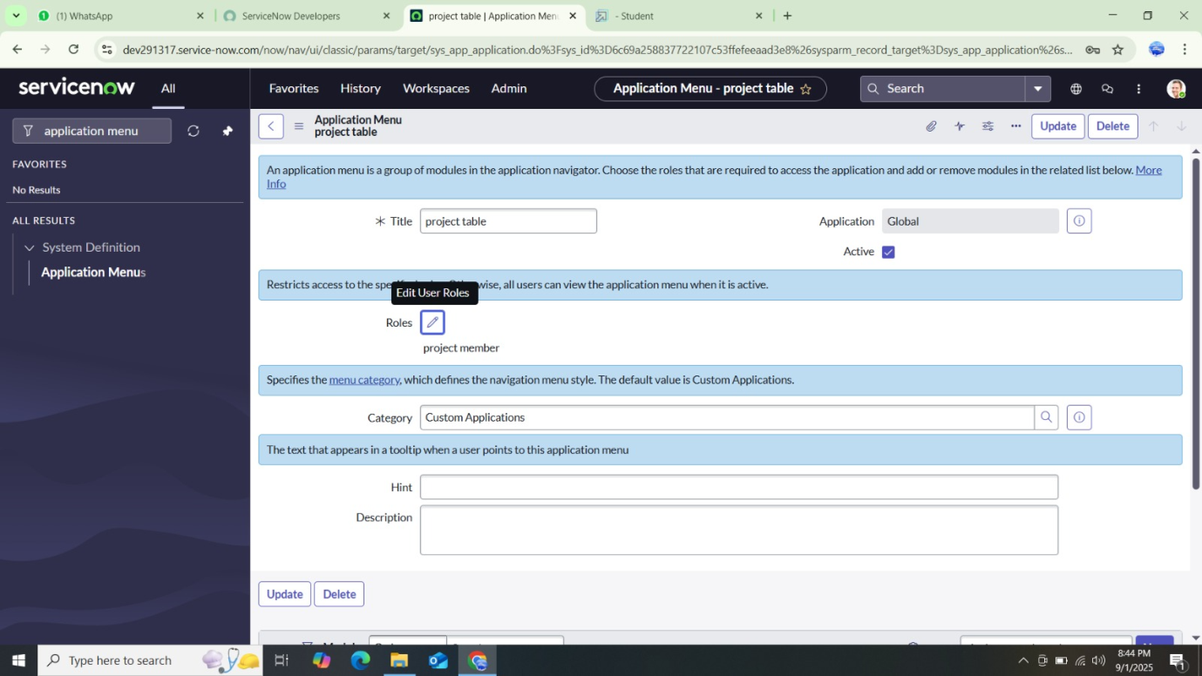

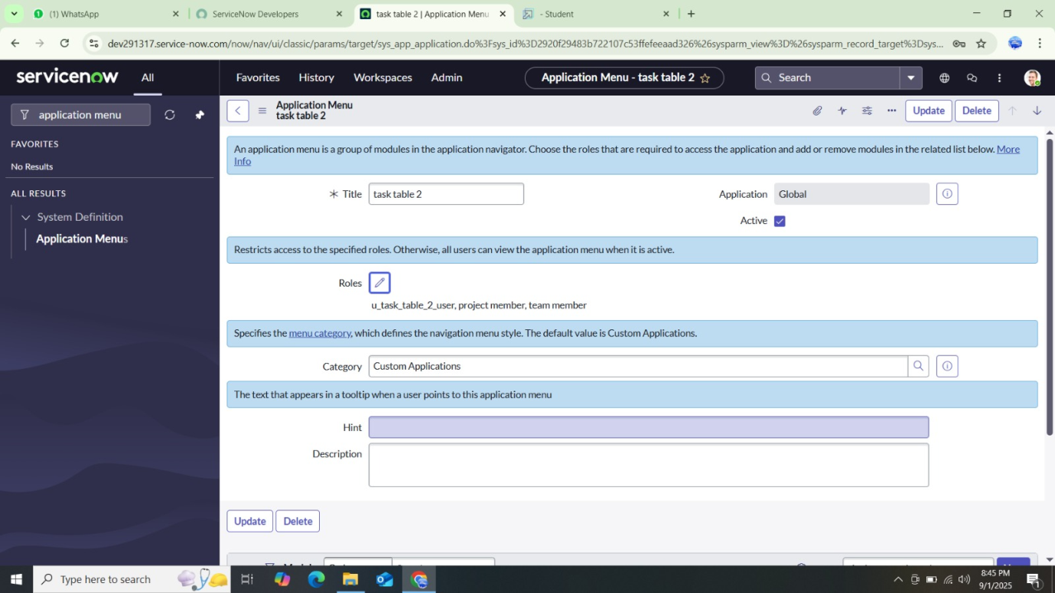

ACCESS CONTROL LIST

**How to Create an ACL in ServiceNow**

1. Open ServiceNow.

2. Go to All → search “ACL”.

3. Select Access Control (ACL) under System Security.

4. Click Elevate Role (to gain security_admin access)

5. Click New to create an ACL.

6. Fill in the required details.

7. Scroll to Requires Role → double-click to add a new row.

8. Select the Task Table and assign the Team Member role.

9. Click Submit.

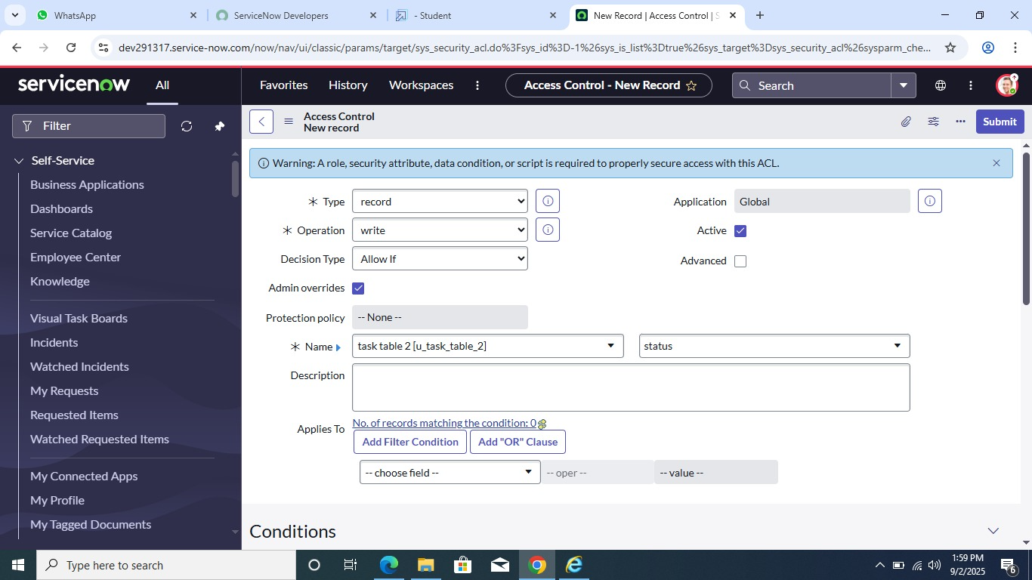

# Create Additional ACLs

Repeat the same steps to create 4 ACLs for the required fields.

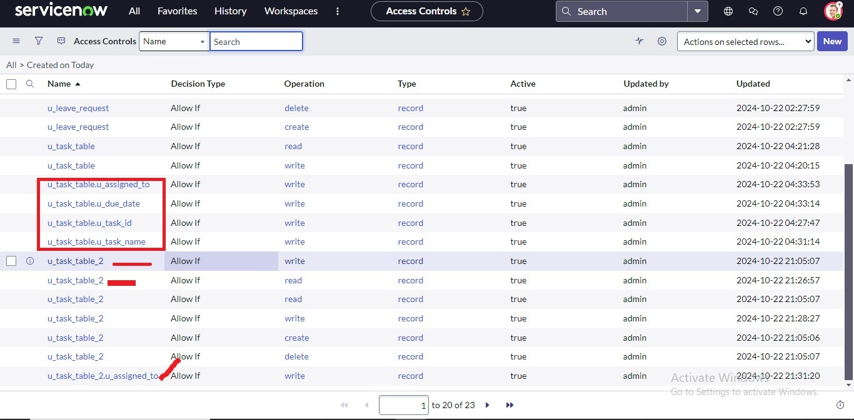

# Test the ACLs

1. Click the Profile Icon (top right).

2. Select Impersonate User → Bob.

3. Go to All → Task Table 2 in the Application menu.

4. Check that Comment and Status fields now have edit access.

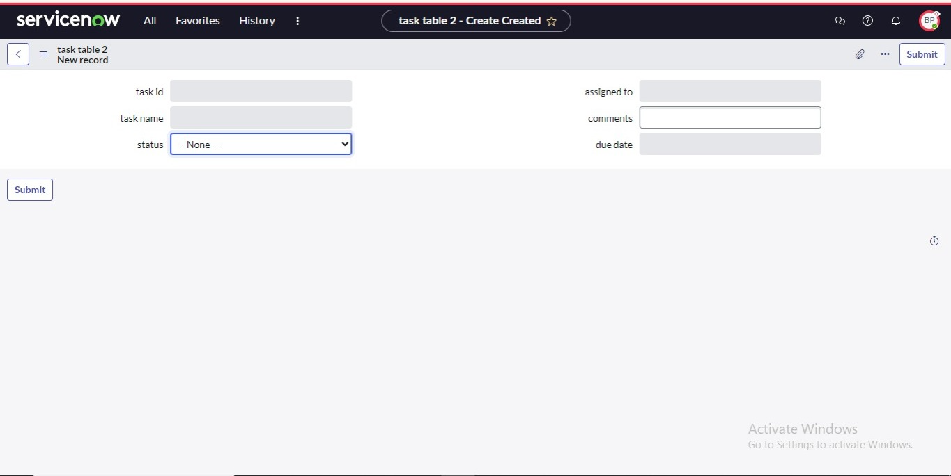

FLOW

**How to Create a Flow to Assign Operations Ticket to a Group in ServiceNow**

# Step 1: Create the Flow

1. Open ServiceNow.

2. Go to All → search “Flow Designer”.

3. Select Flow Designer under Process Automation.

4. Click New → Flow

5. In Flow Properties:

Flow Name: task table

Application: Global

6. Click Build Flow.

# 

# 

# Step 2: Add a Trigger

1. Click Add Trigger.

2. Search for and select Created Record.

3. set**Table:** task table

## Conditions:

Field: Status → Operator: is → Value: in progress

Field: Comments → Operator: is → Value: feedback

Field: Assigned To → Operator: is → Value: Bob

4. Click Done

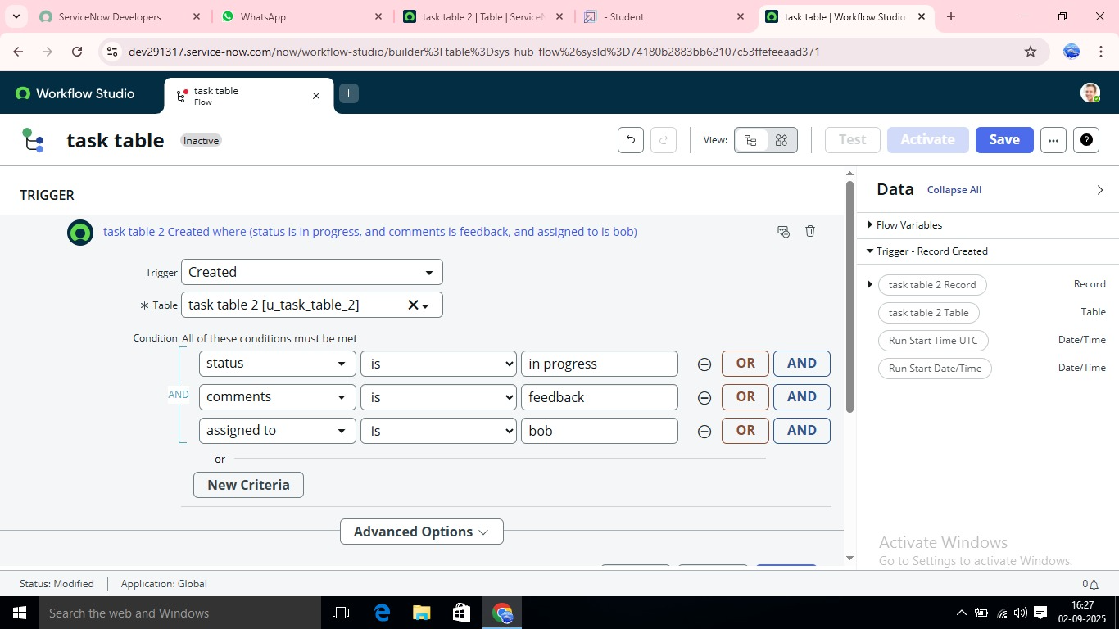

# Step 3: Add First Action (Update Record)

1. Click Add Action.

2. Search for Update Records.

3. In the Record field, drag the record from the Data Pill (right side).

4. The table auto-fills.

5. Add field:

Status → Completed

6. Click Done.



# Step 4: Add Second Action (Approval)

1. Under Actions, click Add Action.

2. Search for Ask for Approval.

3. In the Record field, drag the record from the Data Pill (right side).

4. Table auto-fills.

5. Configure:

Approval Field: Status

Approver: Alice P

6. Click Done.

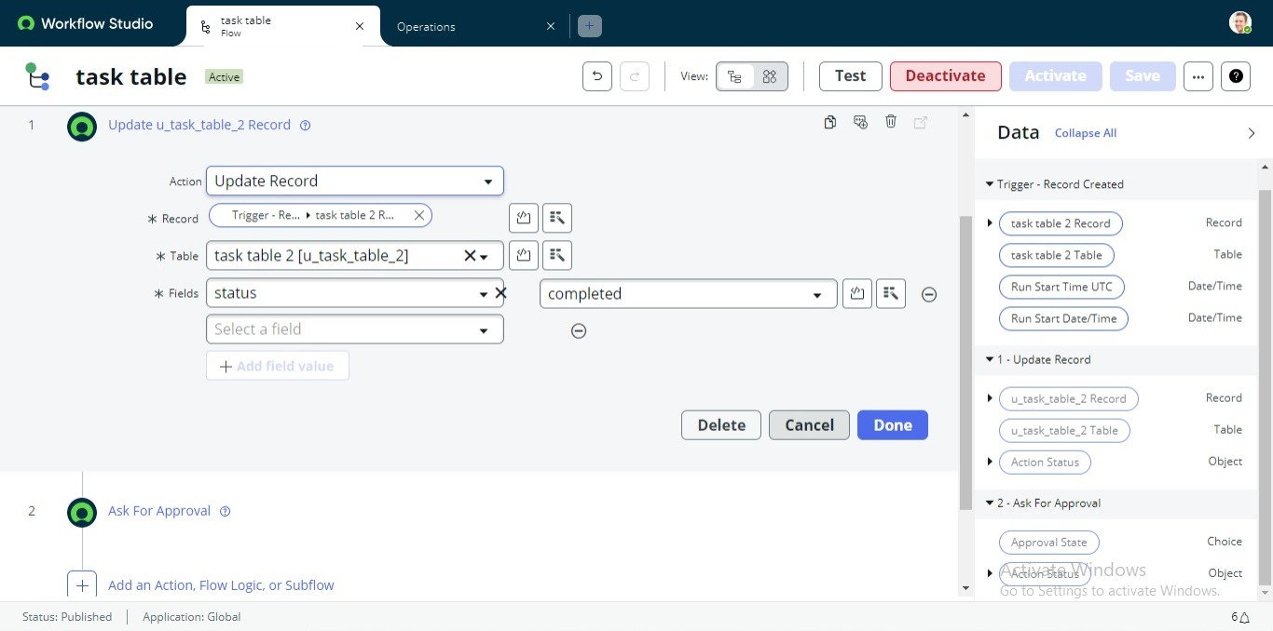

# Step 5: Test the Flow

1. In the Application Navigator, search for Task Table.

2. Confirm that the Status field updates to Completed.

3. In the Application Navigator, search for My Approvals.

4. Click My Approvals under Service Desk.

5. Verify Alice P received the approval request.

6. Right-click on the request → select Approved.

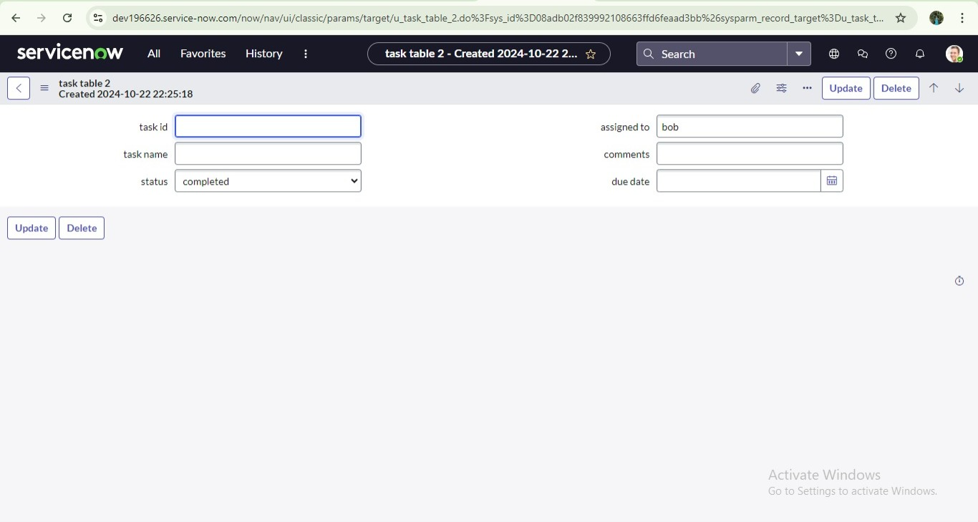

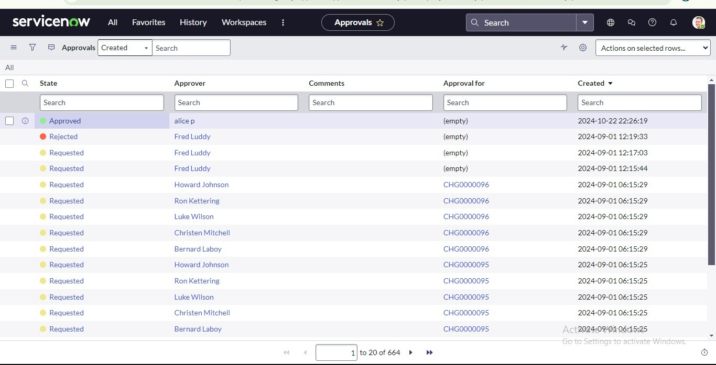

# CONCLUSION

This scenario highlights a structured approach to project management, showcasing the roles of Alice and Bob within a defined workflow. With Alice's oversight and Bob's execution, the team effectively collaborates to ensure project success. The use of tables organizes key information, facilitating easy tracking of projects, tasks, and progress updates. Overall, this system promotes accountability, enhances communication, and leads to the successful completion of projects.